DOIs: --:-- Research Paper / Article

"Increasing Women's Digital Literacy to Prevent Cybercrime
through Community Counseling

^{1*}Nurul Kamilah, ²Dewi Primasari, ³Freza Riana, ⁴Erwin Hermawan, ⁵Jejen Jaenudin
^{1,2,3,4}Informatics Engineering, Faculty of Engineering and Science, Universitas Ibn Khaldun Bogor, Bogor, Indonesia
⁵Information System, Faculty of Engineering and Science, Universitas Ibn Khaldun Bogor, Bogor, Indonesia

Email: ¹nurul.kamilah@uika-bogor.ac.id, ²dewi.primasari@uika-bogor.ac.id, ³freza@uika-bogor.ac.id, ⁴rwien.gfm@gmail.com, ⁵zen@uika-bogor.ac.id
Abstract: The development of information technology has driven increased social media use among various groups, including housewives. However, unwise use of social media can have various negative impacts, such as the spread of cybercrimes, hoaxes, privacy violations, and a decline in the quality of social interactions. This community service activity aims to improve digital literacy by educating women at the Majlis Ta'lim Al-Barokah Islamic study group on the wise use of social media. The method used is educational counseling with a lecture approach and interactive discussions. Evaluation done using pre-tests and post-tests on 30 participants. The results showed an increase in the average score from 2.7 to 4.13. Analysis using N-Gain yielded a score of 0.78, which is considered high. This indicates that the outreach activities were effective in increasing participants' understanding of the wise use of social media.

Keywords: cybercrimes; digital literacy; social media

- INTRODUCTION
Majlis Ta'lim Al-Barokah is a community-based Islamic study group located in Bogor Regency, West Java, whose members are predominantly housewives. In their daily activities, most participants actively use smartphones and social media applications such as WhatsApp (100%), Facebook (30%), and Instagram (45%) to communicate, obtain information, and conduct online shopping. The group consists of approximately 30 active members, most of whom are housewives aged between 35-65 years. However, initial observations and informal discussions conducted by the community service team before the program revealed that many participants had limited awareness of digital security.
Several participants admitted that they frequently received suspicious messages (18 members), promotional links (9 members), and requests for personal information through social media and instant messaging applications (2 members) but were unable to distinguish between legitimate and fraudulent content. In addition, participants had limited knowledge of protecting personal data, identifying online scams, and verifying information before sharing it with others. These conditions indicate that members of Majlis Ta'lim Al-Barokah are vulnerable to various forms of cybercrime and therefore require practical digital literacy education tailored to their daily needs.
The conditions identified during the preliminary observation are consistent with previous studies reporting that housewives are among the community groups vulnerable to cybercrime due to limited digital literacy, inadequate awareness of information security, and high levels of trust in information circulated through social media (Hidayat et al., 2023). As social media has become an essential platform for communication, information exchange, and online transactions, insufficient digital literacy may increase the risk of online fraud, personal data theft, identity misuse, and the spread of misinformation (Harahap & Zikri, 2025; Bada & Nurse, 2021). Therefore, improving digital literacy is an important preventive strategy to enhance the community's ability to recognize cyber threats and use digital technology safely and responsibly (Belshaw, 2014; Ramadhany et al., 2025).
Several studies have shown that digital literacy levels are significantly related to cybercrime awareness. Individuals with good digital literacy tend to be better able to identify invalid information and are more cautious in their digital interactions (Subagio et al., 2025). Conversely, low digital literacy can increase vulnerability to various forms of cybercrime. Therefore, improving digital literacy is a key strategy in preventing cybercrime in society (Kusuma et al., 2022).
Efforts to improve digital literacy can be implemented through various approaches, one of which is through direct outreach or education activities for the community. Outreach activities are considered effective because they allow for two-way interaction between the presenter and participants, thus facilitating the process of understanding and clarifying information (Riana et al., 2022). Furthermore, outreach accompanied by real-life case studies relevant to everyday life can increase participants' absorption of the material presented (Rufli et al., 2024).
Social media offers various benefits, such as ease of communication, rapid access to information, and opportunities to expand social networks. However, using social media without adequate digital literacy skills can lead to various problems, such as the spread of hoaxes, hate speech, cyberbullying, and digital privacy violations (Nasrullah, 2017). In the context of community service, digital literacy outreach activities play a strategic role in increasing community capacity to face the challenges of the digital era.
Several studies have shown that digital literacy education programs can significantly improve public understanding, particularly regarding the wise and safe use of social media (Nisa et al., 2025). This demonstrates that the right educational approach can have a real positive impact on society. Majlis Ta'lim, as a form of religious community, has significant potential as a medium for disseminating digital literacy education. Regular religious study sessions are an effective means of conveying information to the community, particularly mothers. By utilizing this forum, digital literacy education can be more targeted and contextualized, tailored to the needs of participants. Furthermore, a community-based approach can also increase participants' trust and active participation in educational activities.
Based on this background, this community service activity focused on improving digital literacy to prevent cybercrime through outreach to women at the Majlis Ta'lim Al-Barokah Islamic study group. This activity is expected to increase participants' understanding of the safe and responsible use of social media and raise awareness of various potential cybercrime threats. Thus, this community service activity not only contributes to improving public digital literacy but also provides practical insights into cybercrime prevention efforts at the community level. Furthermore, the results of this activity are expected to serve as a reference for implementing similar community service programs in the future, particularly those focused on improving digital security and public literacy in the era of digital transformation.
- METHOD
This community service activity employed a descriptive quantitative approach with an educational outreach method to improve digital literacy and cybercrime prevention among women attending the Majlis Ta'lim Al-Barokah religious study group. This method was chosen because it is considered effective in providing direct understanding to the community through two-way interaction between the presenter and participants (Riana et al., 2022). Furthermore, this approach allows for measurable evaluation through pre- and post-test instruments. The activity flow diagram of community service program is described in Figure 1.
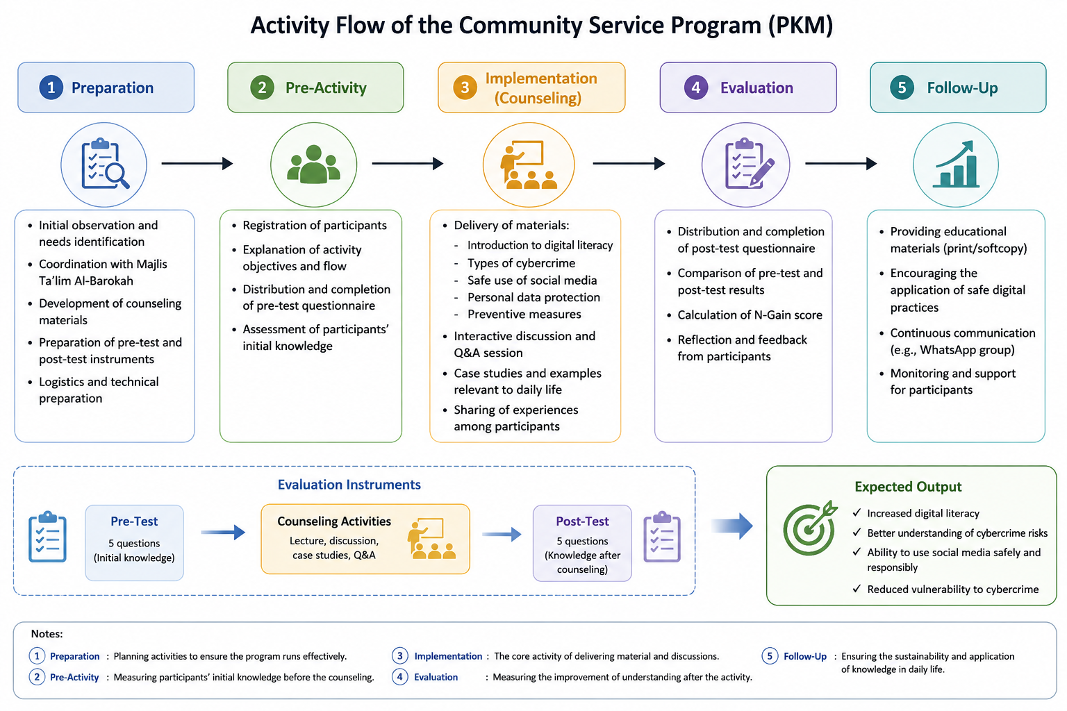
Figure 1. PKM Activity Flow Diagram

This activity was held at the Majlis Ta'lim Al-Barokah in Bogor Regency, West Java Province. It took place on December 27, 2025, and lasted one day, consisting of three main stages: preparation, implementation, and evaluation. The total duration of the activity was approximately 2–3 hours, covering the presentation of materials, interactive discussions, and completion of evaluation instruments. The subjects in this activity were women who joined the regular religious study activities of Majlis Ta'lim Al-Barokah with a total of 30 participants, because the member of Majlis Ta'lim Al-Barokah only 30 persons.
The sample selection technique used the purposive sampling method, namely the selection of participants based on certain criteria, including actively participating in religious study activities and using social media in their daily activities. The selection of this technique was based on the consideration that this group is a relevant target and vulnerable to the risk of cybercrime, thus aligning with the objectives of the activity (Sugiyono, 2019).
Data collection was conducted using several techniques, including observation, documentation, and questionnaires. Observations were conducted initially to identify participants' level of understanding regarding social media use and potential cybercrime risks. Documentation was used to record the activities, including the outreach process and participant participation. The main instrument used was a pre-test and post-test questionnaire consisting of five questions related to digital literacy and cybercrime understanding.
The pre-test was administered before the training to measure participants' initial knowledge, while the post-test was administered after the training to determine improvements in understanding. This evaluation model refers to a learning evaluation approach commonly used in educational activities (Arikunto, 2018). The instrument's validity was tested through content validity, ensuring that each question aligns with the digital literacy indicators and cybercrime aspects being measured.
The instrument's development was based on the concept of digital literacy, which encompasses information literacy, digital security, and social media ethics (Desiany et al., 2024). Furthermore, expert judgment was consulted to ensure the instrument's content was appropriate. The validity of the questionnaire was established through content validity by involving two expert validators. The validators consisted of one lecturer specializing in digital literacy and one lecturer specializing in educational evaluation, who independently reviewed the relevance, clarity, and appropriateness of each questionnaire item.
The instrument was developed based on the digital literacy framework, which includes information literacy, digital security, and social media ethics (Desiany et al., 2024). Each validator evaluated whether the questionnaire items adequately represented the intended constructs and were suitable for the characteristics of the target participants. Revisions were made based on the validators' suggestions to improve the clarity of wording and ensure that the instrument accurately measured participants' understanding of digital literacy and cybercrime prevention.
The reliability of the questionnaire was ensured through a careful instrument development process. All questionnaire items were written using clear and simple language, following the same format and level of difficulty to facilitate consistent understanding among participants. Before implementation, the questionnaire was reviewed together with the content validation process to ensure that the wording of each item was unambiguous and appropriate for the educational background of the target community. This approach was considered adequate for maintaining the consistency of the instrument in the context of community service evaluation.
The activities were implemented in three main stages: Preparation, Implementation, and Evaluation. In the Preparation stage, initial observations were conducted, counseling materials were developed, and evaluation instruments were created. The materials included an introduction to digital literacy, types of cybercrime, and how to prevent it on social media. In the Implementation stage, a pre-test was administered to participants, followed by counseling using lecture and interactive discussion methods. The materials were delivered using real-life case studies relevant to participants' daily lives, such as online fraud and misuse of personal data. This method aimed to improve participants' understanding contextually.
In the Evaluation stage, participants were asked to complete a post-test to measure their understanding. In addition, a reflective discussion was conducted to determine participants' responses to the activities. Data obtained from the pre-test and post-test were analyzed using quantitative descriptive methods. Participants' scores were averaged to determine their level of understanding before and after the activity. Next, an analysis was conducted using the N-Gain formula to measure the effectiveness of learning outcomes.
The N-Gain calculation refers to the formula developed by Hake (1999), namely:
$N-Gain=\frac{\left(Skor Post test-Skor Pre Test\right) }{(Skor Maksimal-Skor Pre Test) }$… (1)

The N-Gain value was then categorized into three levels: high (≥0.7), medium (0.3–0.7), and low (<0.3). This analysis was used to determine the effectiveness of the outreach program in improving participants' digital literacy. The data obtained from the pre-test and post-test questionnaires were analyzed using descriptive quantitative analysis. The calculation of participants' average scores and the N-Gain values was performed using Microsoft Excel. The analysed data were then presented in tables and graphs to facilitate interpretation of the results and to provide a clear overview of the effectiveness of the community service program in improving participants' understanding of digital literacy and cybercrime prevention.
- RESULT AND DISCUSSION
The community service activity was conducted with 30 participants at the Majlis Ta'lim Al-Barokah women's religious study group. The activity aimed to improve digital literacy and cybercrime prevention through educational and participatory outreach. The activity was conducted in one main session, which included material delivery, interactive discussion, and an assessment of participant understanding.
In the initial stage, participants were given a pre-test to gauge their initial understanding of digital literacy and cybercrime. The activity then continued with the delivery of material covering an introduction to digital literacy, common types of cybercrime, and preventative measures that can be taken when using social media. The material was delivered using a contextual approach tailored to the participants' daily lives. Each participant received printed cybercrime materials (Figure 1).
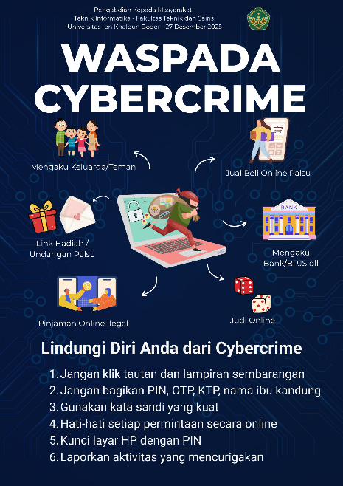
Figure 2. PKM materials distributed to participants
Throughout the event, participants demonstrated high levels of enthusiasm, evident in their active participation in the discussion and Q&A sessions. Several participants also shared their experiences with online fraud they had experienced or witnessed, enriching the collective learning process. Photos and videos were taken during the event to document the event (Figure 3).
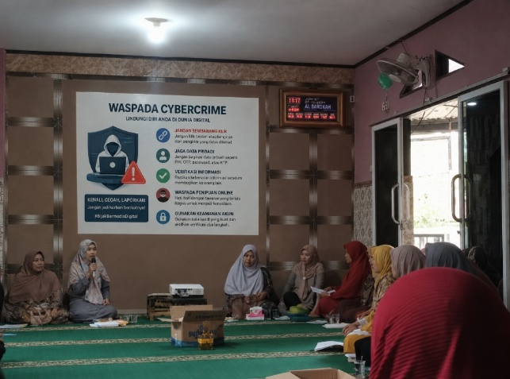
Figure 3. PKM Presentation and Delivering Material
The pre-test results showed that participants' initial understanding of digital literacy and cybercrime was still relatively low. Out of a maximum score of 5, the average pre-test score was 2.7. This indicates that most participants lacked an adequate understanding of the safe use of social media and the potential risks of cybercrime. Most participants only understood social media as a means of communication and entertainment, unaware of the potential threats such as online fraud, personal data theft, or misuse of information. Furthermore, some participants were unable to distinguish between valid information and hoaxes.
The distribution of pre-test scores shows that the majority of participants fell between 2 and 3, with only a small percentage achieving a score of 4 (Table 1). No participants achieved the maximum score. This situation indicates a significant need for digital literacy education, particularly regarding security when using social media.
Table 1. Summary participant pre-test and post-test results
Stages | Average | Minimum Score | Maximum Score
Pre-test | 2.70 | 1 | 4
Post-test | 4.13 | 1 | 5

After implementation counseling, post-test was conducted for measure improvement understanding participants. The results show existence significant increase in the value obtained participants. The average post-test score increased to 4.13 from a maximum score of 5 (Figure 4).
Most participants were able to correctly answer questions related to types of cybercrime, such as phishing, online fraud, and misuse of personal data. Furthermore, participants demonstrated a better understanding of preventative measures, such as maintaining the confidentiality of personal data, not easily trusting unverified information, and exercising caution when conducting online transactions. The distribution of post-test scores showed that the majority of participants scored between 4 and 5, with some achieving the maximum score. This indicates a widespread increase in understanding among participants after participating in the outreach activities.
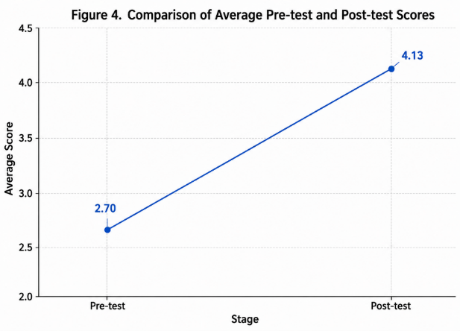
Figure 4. Graph of Improvement in Pre-test and Post-test Results
This value is considered high, indicating that the outreach activities were effective in improving participant understanding. To determine the effectiveness of the outreach activities, an analysis was conducted using the N-Gain method. The calculation yielded an N-Gain value of 0.78 (Table 2), which falls into the high effectiveness category. This substantial improvement can be attributed to several factors. First, most participants had limited prior knowledge of digital literacy and cybercrime prevention, as identified during the preliminary observation, resulting in relatively low pre-test scores and providing considerable room for improvement. Second, the educational sessions employed simple language, practical examples, and interactive discussions that were closely related to the participants' daily experiences, such as online shopping fraud, phishing messages, and social media scams.
These contextual learning strategies enabled participants to better understand and retain the information presented. Furthermore, the question-and-answer sessions encouraged active participation, allowing participants to clarify misconceptions and directly relate the material to real-life situations. These factors collectively contributed to the significant increase in participants' post-test scores and the high N-Gain value.
Table 2. Summary participant pre-test and post-test results
Parameter | Mark
N-Gain | 0.78
Category | High
The N-Gain score is calculated based on the difference between the pre-test and post-test scores normalized against the maximum score. These results indicate that most participants experienced significant improvements in their understanding of digital literacy and cybercrime. Furthermore, the consistent improvement in scores across nearly all participants demonstrates that the outreach method was able to reach a range of participants' initial levels of understanding. No participants experienced a decline in scores, thus concluding that the activity had a positive impact overall.
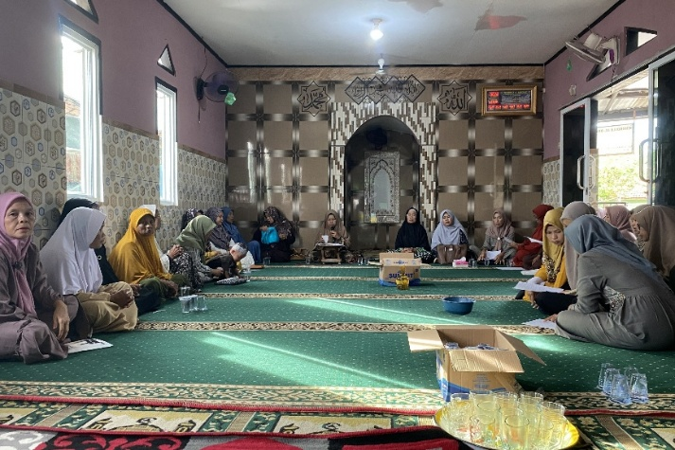
In addition to quantitative improvements in scores, this activity also demonstrated changes in participants' behaviour and awareness. This was evident in their responses during the discussion and post-activity reflection sessions. Several participants stated that they had become more cautious when using social media, particularly when sharing personal information and responding to messages from unknown sources. Participants also demonstrated increased awareness of the importance of maintaining account security, such as using strong passwords and not sharing verification codes with others.
Figure 5. Documentation of PKM activities delivering material and questions and answers
Furthermore, participants demonstrated their ability to identify potential online fraud based on the case studies provided. This was evident in their ability to answer the case study questions posed during the discussion session. This change shows that the outreach activities not only increase participants' knowledge, but also have an impact on aspects of awareness and attitudes in facing cybercrime risks.Figure 5 illustrates participants' active engagement throughout the counseling session. The photographs show interactive discussions, participant involvement during question-and-answer sessions, and direct communication between facilitators and community members. The high level of participation observed during these activities reflects participants' enthusiasm and indicates that the educational approach successfully created an inclusive learning environment. The documentation also demonstrates community-based
encouraged participants to discuss real cybercrime experiences openly. Such interaction is considered essential for promoting reflective learning and strengthening participants' confidence in applying digital safety practices in their daily lives.
- CONCLUSION
The community service program successfully improved participants' understanding of digital literacy and cybercrime prevention. The evaluation results showed that the average participant score increased from 2.70 in the pre-test to 4.13 in the post-test. Furthermore, the N-Gain value of 0.78 indicates that the educational intervention was highly effective in enhancing participants' knowledge. These findings demonstrate that the counseling approach, which combined contextual explanations, practical examples, and interactive discussions, was well suited to the participants' needs and contributed to the significant improvement in learning outcomes. To ensure the sustainability of these positive impacts, future community service programs should include continuous mentoring, periodic follow-up activities, and broader participation from other community groups to strengthen digital literacy and cybercrime prevention awareness.
ACKNOWLEDGMENT
The authors express sincere gratitude to the management and members of Majlis Ta'lim Al- Barokah for their active participation and support during the community empowerment activities. Appreciation is also extended to all parties who contributed to the implementation of this program. This study did not receive specific grants from funding agencies in the public, commercial, or non-profit sectors.
CONFLICT OF INTERESTS
The authors declare that there are no conflicts of interest related to this study. There are no financial, commercial, professional, or personal relationships that could have influenced the design, implementation, analysis, or reporting of this community empowerment activity. The research was conducted independently and objectively.
REFERENCES
Bada, M., & Nurse, J. R. C. (2021). The social and psychological impact of cyber-attacks. Journal of Cybersecurity, 7(1), 1–12. https://doi.org/10.1093/cybsec/tyab001
Bakrie, A. K., & Cempaka, L. (2023). Literasi digital dalam masyarakat. Jurnal Multidisiplin, 2(1), 10–18.
Belshaw, D. (2014). The essential elements of digital literacies. Self-published. https://ecampusontario.pressbooks.pub/app/uploads/sites/2017/2021/09/The-essential-elements-of-digital-literacies_-Doug-Belshaw-at-TEDxWarwick.docx
Desiany, M., Komalasari, K., & Anggraini, D. N. (2024). The influence of cyber culture on students' digital literacy. JIPSINDO (Jurnal Pendidikan Ilmu Sosial Indonesia), 11(1), 45–56.
Harahap, R. H., & Zikri, M. A. (2025). Online identity and cybercrime: Unmasking threats in the digital age. Journal of Communication and Cyber Studies, 3(1), 15–27.
Hidayat, T., Sari, M., & Putra, A. (2023). Perilaku pengguna media sosial dan risiko kejahatan siber. Jurnal Komunikasi Digital, 5(2), 101–110.
Kurniasih, N. (2023). Literasi media sosial: Upaya pencegahan pemalsuan identitas digital. Jurnal Pengabdian Masyarakat, 4(1), 55–62.
Kusuma, C. S. D., Prasetyo, B., & Nugroho, Y. (2022). Strengthening digital literacy to prevent hoax and cybercrime. In Proceedings of the International Conference on Education Research and Innovation (pp. 210–215). Atlantis Press.
Nasrullah, R. (2017). Media sosial: Perspektif komunikasi, budaya, dan sosioteknologi. Simbiosa Rekatama Media.
Nisa, A. Z. K., Rahmawati, D., & Lestari, S. (2025). Penyuluhan bijak bermedia sosial dalam meningkatkan literasi digital masyarakat. Jurnal Pengabdian Masyarakat, 6(1), 25–33.
Nurrahmi, F., Putri, A., & Saputra, H. (2025). Digital skill and digital safety in combating online fraud. Jurnal Komunikasi, 17(1), 1–12.
Pratiwi, N., Wibowo, A., & Santoso, R. (2023). Edukasi literasi digital pada masyarakat desa. Jurnal Abdimas Indonesia, 5(2), 88–96.
Ramadhany, A. F., Nugraha, D., & Firmansyah, R. (2025). Digital literacy as a cyber crime defense and prevention strategy. International Journal of Information and Communication Technology, 10(1), 50–60.
Ratri, S. Y., & Aviyanti, L. (2025). Unlocking digital literacy in Indonesia: Insights from the use of social media platforms. Jurnal Prima Edukasia, 13(1), 12–25.
Riana, D., Hidayat, R., & Saputri, N. (2022). Penyuluhan literasi media dalam meningkatkan pemahaman masyarakat. Jurnal Abdimas, 3(2), 67–74.
Rufli, M., Ananda, R., & Prasetyo, E. (2024). Sosialisasi cybercrime dan keamanan data pribadi pada masyarakat. Jurnal Pengabdian Kepada Masyarakat, 5(1), 40–48.
Sari, M., Hidayat, T., & Putra, A. (2024). Keamanan data pribadi di era digital. Jurnal Teknologi Informasi dan Komunikasi, 6(1), 70–80.
Setiawan, D., Nugroho, Y., & Firmansyah, R. (2024). Digital risk awareness in social media users. Journal of Digital Society, 2(1), 33–41.
Subagio, A., Pratama, B., & Kurniawan, D. (2025). Digital literacy effects on cybercrime awareness. Kalbisocio: Jurnal Bisnis dan Komunikasi, 12(1), 77–85.
Thomas, P. B., Hogan-Taylor, C., Yankoski, M., & Weninger, T. (2021). Online media literacy programming reduces belief in false news in Indonesia. Journal of Media Literacy Education, 13(2), 1–14. doi: https://dx.doi.org/10.5210/fm.v27i1.11683
Wibowo, A., Santoso, R., & Pratiwi, N. (2022). Perlindungan pengguna internet dari ancaman cybercrime. Jurnal Teknologi dan Informasi, 4(2), 120–130.

